**Blower: -**

**RMSE: -**

Train Score: 4850.60 RMSE

Test Score: 5494.35 RMSE

**Predictions: -** Orange line is for train and Green is for test

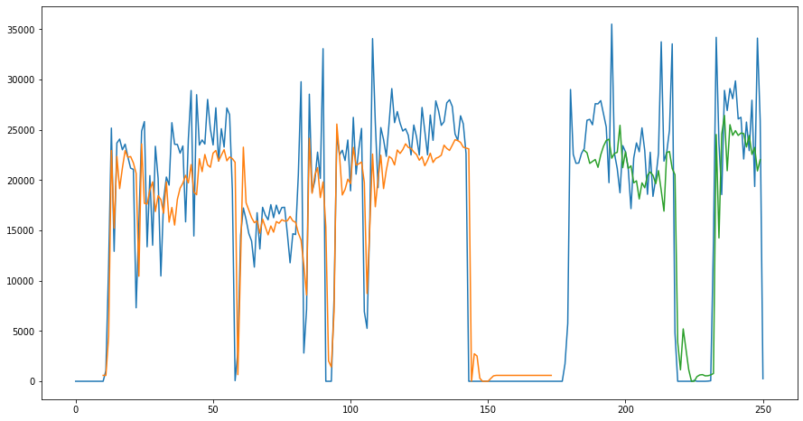

**Forecast for next 24 hrs. with 10 timesteps: -**

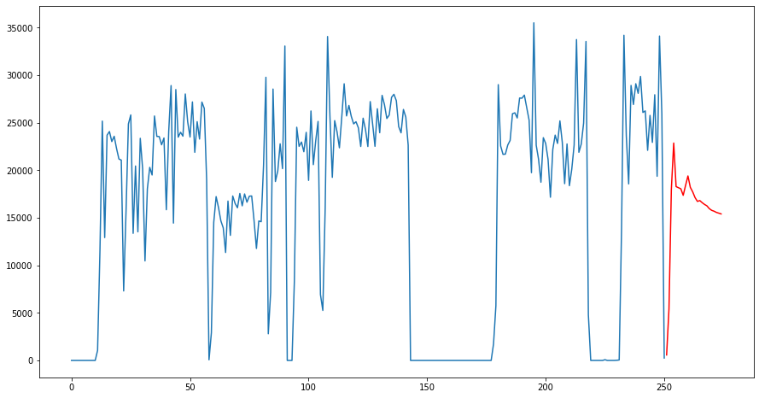

**Filler: -**

**RMSE: -**

Train Score: 6770.66 RMSE

Test Score: 7971.38 RMSE

**Predictions: -** Orange line is for train and Green is for test

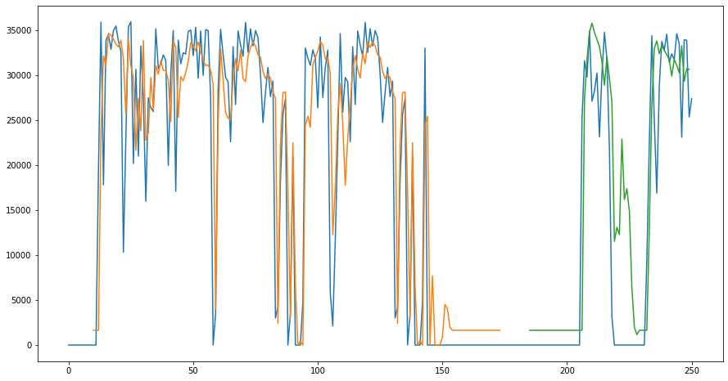

**Forecast for next 24 hrs. with 10 timesteps: -**

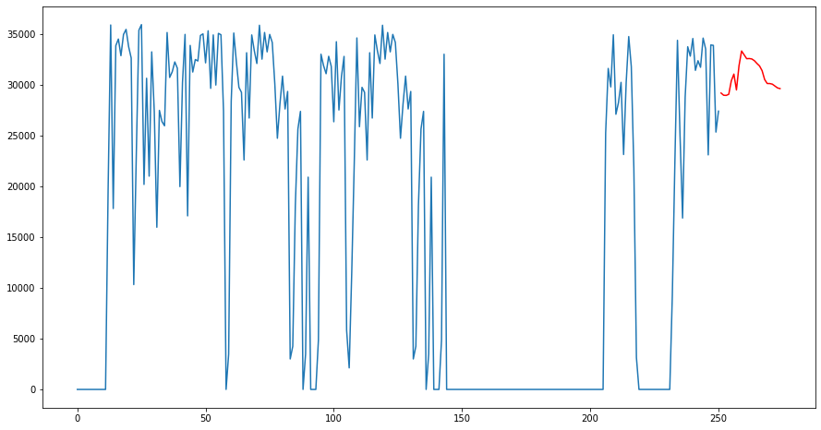

**Labeller: -**

**RMSE: -**

Train Score: 5695.62 RMSE

Test Score: 6633.10 RMSE

**Predictions: -**

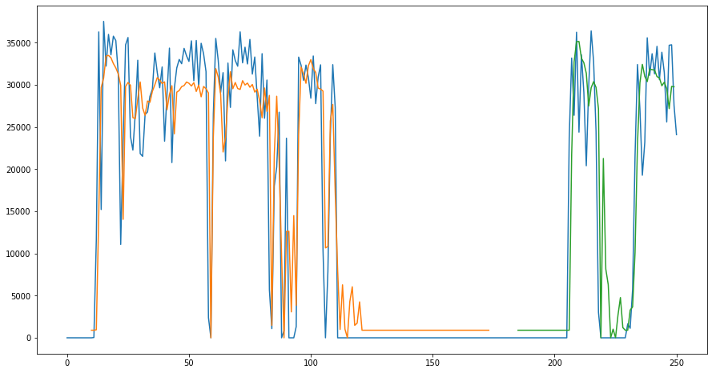

**Forecast for next 24 hrs. with 10 timesteps: -**

